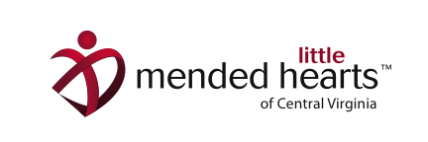
Bravery Bag Drive for Little Hearts

Mended Little Hearts (MLH) is a non-profit organization for families of children affected by congenital heart defects and disease. We provide support, education, advocacy and awareness. Congenital heart defects (CHD) are the #1 birth defect and affect 1 in 110 children. Nearly 25% of these kids will need heart surgery or other medical intervention.

Our group delivers Bravery Bags to the families while they are in the hospital with their child. Bravery Bags are full of items to make the family’s hospital stay easier, but mostly to let them know they are not alone—we have been through this journey too and can help.

We are in need of the following items:

PLAYING CARDS
COLORED PENCILS
CRAYONS (16 OR 24 COUNT)
*WASHABLE MARKERS
*COLORING BOOKS
STICKERS/STICKER BOOKS
*ADULT ACTIVITY BOOKS
*LIP BALM
*BODY WASH (TRAVEL SIZE)
SHAMPOO & CONDITIONER (NO GREATER THAN 5oz)
*MEN’S AND WOMEN’S DEODORANT
*ADULT TOOTHBRUSHES
*DENTAL FLOSS
*TRAVEL SIZE TISSUE PACKS
- We are in short supply and need these items the most.

If you have any questions please contact Megan Perkins at mendedlittleheartcva@gmail.com.
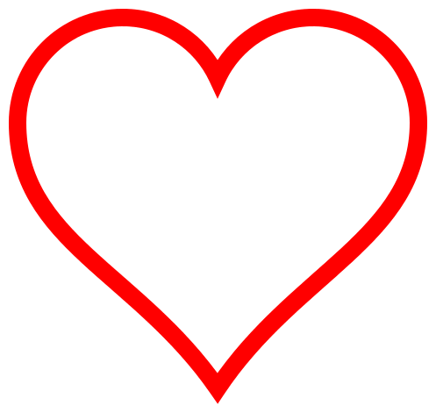
Like us on Facebook at Mended Little Hearts of CVA or visit our website at mendedlittleheartscva.org.

Thank you so much for your support!!!!!

